**Instructions**: Please use the template below to prepare your abstract in doing so, please note the following:

1. The abstract must be submitted in .docx or .doc format. Pdf files will not be accepted.
2. You may include 1-2 figures.
3. Your abstract, including figures, can be no longer than one A4 page.

**Please delete these instructions before submitting your abstract**

# Heading/title (Arial, bold font size 12 pt, centered)

Lead Author*, Co-authors2 (Arial, font size 11pt, centered)

1Affiliation (Arial, font size 11 pt, centered)

2Affiliation (Arial, font size 11pt, centered)

* mail@mail.com (Arial, font size 11pt, centered)

## Abstract (Arial Bold, font size 10pt, full justification)

Write here your abstract in Arial font size 10 pt, full justification.

Fluorophores in the near infrared window (650-900 nm) offer improved tissue penetration . . .

Add your figures/tables here (optional)

Captions in Arial, font size 10 pt, full justification

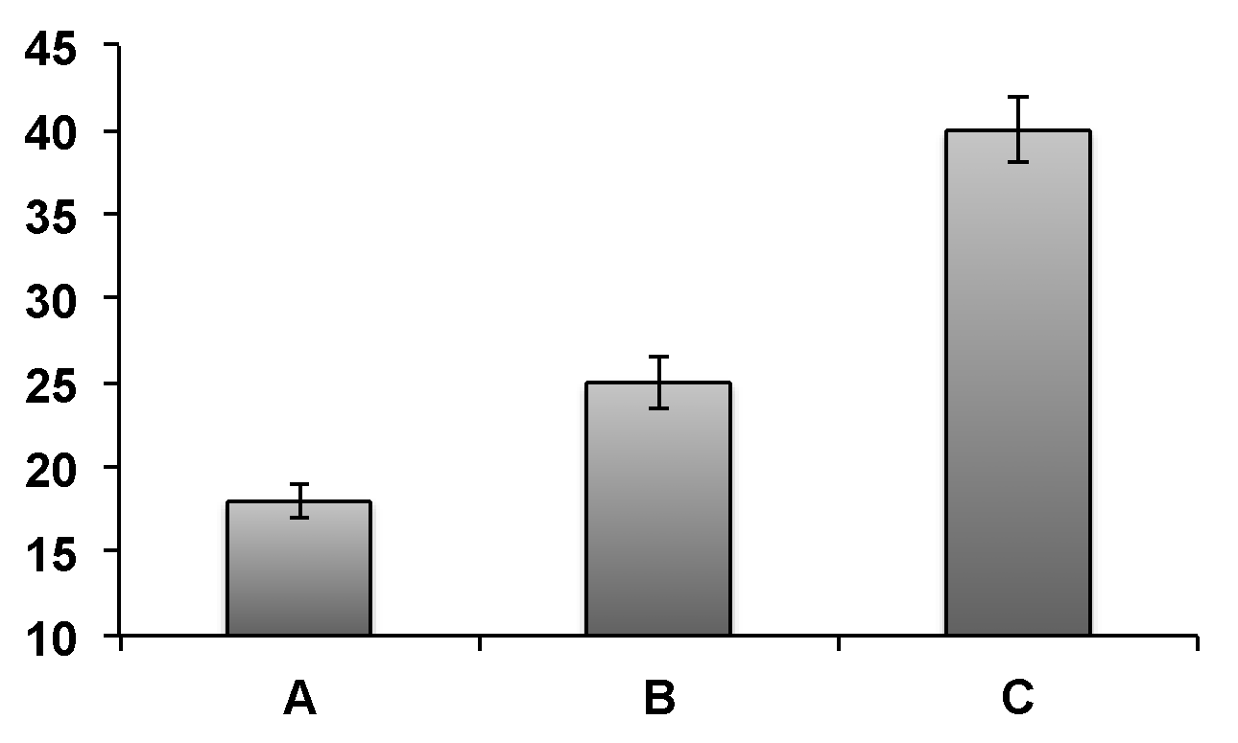

Figure 1. (Arial, font size 10pt, full justification)

## References (Arial Bold, font size 10pt, full justification)

Write your references here in Arial, font size 10 pt, full justification

[1] J. Allmer, C.H. Markert, E.J. Stauber, M. Hippler, FEBS Letters 562 (2004) 202–206.

## Acknowledgements (Arial Bold, font size 10pt, full justification)

The author wishes to thank . . .